 |  | Newsletter | 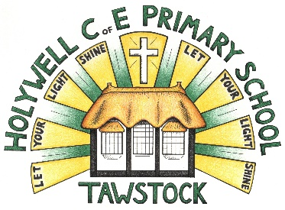  LET YOUR LIGHT SHINE  www.primaryschoolsbarnstaple.co.uk  holywell@ventrus.org.uk

20th February 2024
Holywell is a NO NUT Zone.

Message from Mrs. Lowrey

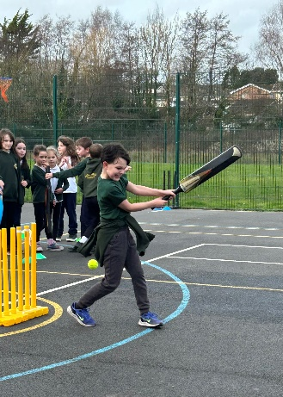
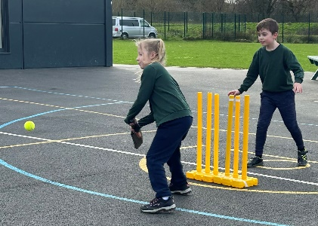
What a fantastic week following half term, despite the frustrating downpours! We had a super day on Tuesday with Martin Brice leading the day of cricket festival at the school! The children had an amazing day and I know that Martin was very impressed with the excellent sportsmanship of the children. I was so proud to see how some of our children were real naturals at the sport! I do think some children have been inspired to take it up – well done everyone on such a fantastic day. It was also fantastic to see how we could also share some of our day with Roundswell and to have their children involved as well.

On Thursday, Mr Day also led the Parkrun assembly for both schools, which was so nice to see! Our children are very invested in sport and it makes me very proud to see how they are developing their personal interests and choosing a wide range of sports to follow, whether they are team sports or individual pursuits – well done!

Congratulations also to Foxes class, who have produced some excellent science work and also shared their poetry in collective worship today! Mrs Bellew has been working with her class on performance poetry and everyone was very impressed with the performance piece that they put together.
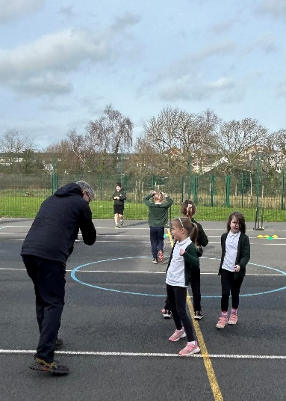
Since my last update before half term, I have now heard that architects are due on site at Holywell on Monday next week. As previously mentioned, the works are currently sitting with insurers to “rubber stamp” proceedings, hence we are still waiting to hear from them. Behind the scenes, there has been a lot happening, with equipment and IT being order to be able to swiftly set up classroom once it is complete. I am still being informed that our return date is for summer term, however, I always add that this is provisional and potentially subject to change. Please do be reassured that, in the event that the works go over this date, we have been offered space at Roundswell during the summer term. However, for the time being, the works are scheduled to be complete by 15th April – all being well. I will provide you with a weekly update from this point as I do understand that families are keen to be informed.

May I take this opportunity to wish the Year 3/4 children a successful residential next week! I am sure that you are all very excited to go and I know that you will have a super time. Please stay safe and make sure that you have fun! Have a wonderful weekend everyone! Mrs Lowrey

School Contact
You can contact the school by phoning 01271 345908. If the phone is not answered, can you please leave a message on the answerphone. These messages will be responded to as soon as possible.

Links you may find useful.
HANDi Paediatric app: advice for common childhood conditions - One Devon

Diary Dates
Thursday 22nd Junior parkrun assembly (HW & RW children) in hall @ 1.15pm.
Wednesday 28th February - ND girls football finals @ Kingsley – selected children
February 26th – February 28th inclusive - Skern Lodge residential
1st March – Rising stars day 2 (selected children)
Thursday March 7th - World Book Day - Dress up and book based activities/Book and Bake sale
Friday 8th March - Year 3 & 4 Girls Football Festival @ Tarka

Wednesday 20th March - Dental Survey – Children Aged Year 5 - Please return the forms sent home.
Thursday 21st March – Holywell and Roundswell cross country festival
Tuesday 26th March - Barnstaple boys football finals @ Tarka

Term Dates
Last day of the Spring Term – Thursday 28th March 2024
First day of the Summer Term – Monday 15th April 2024

School Uniform
https://schoolthreads.org/collections/holywell-c-of-e

PE T-shirts will still be available to purchase from school.

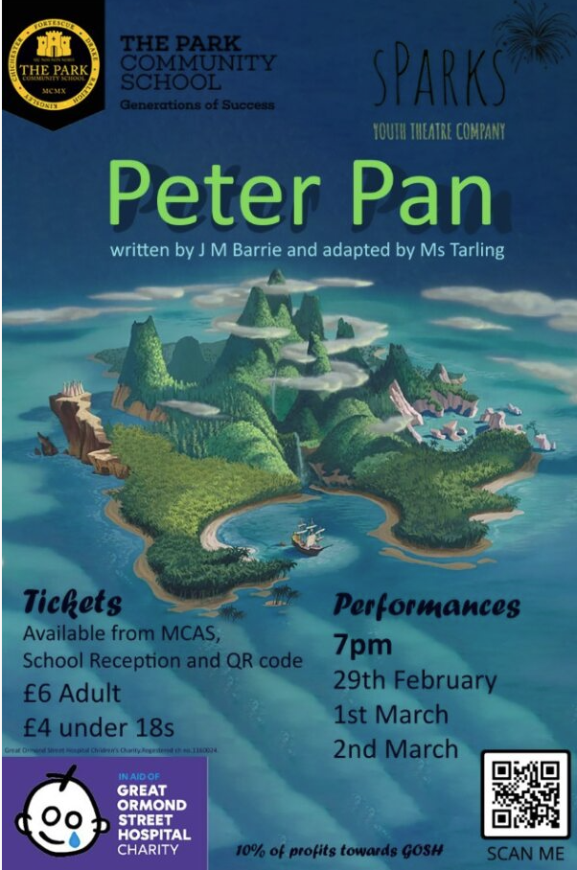

Ventrus Job Vacancies
https://ventrus.current-vacancies.com/v?id=VENTRUSMUL&t=Ventrus-Careers
Including vacancies at local schools.

Free School Meals
Check if your child can get free school meals and additional funding support.
All children in reception, year 1 and year 2 at state schools in England automatically get free school meals. However, parents and guardians are encouraged to apply for free school meals when they enrol their child in school, as this can help their child’s school to attract additional ‘pupil premium‘ funding to support learning.
From year 3 onwards, children whose parents are getting any of the following are entitled to free school meals:
- Universal Credit (provided you have an annual net earned income of no more than £7,400, as assessed by earnings from up to three of your most recent assessment periods).
- Income Support (IS).
- Income-based Jobseekers Allowance (IBJSA).
- Income-related Employment and Support Allowance (IRESA).
- The guaranteed element of State Pension Credit.
- Support under Part VI of the Immigration and Asylum Act 1999.
- Child Tax Credit (provided you’re not also entitled to Working Tax Credit and have an annual gross income that does not exceed £16,190).
- Working Tax Credit run-on (the payment you get for a further 4 weeks after you stop qualifying for Working Tax Credit).

How to apply
Apply through the Devon Citizens Portal. This is the quickest and easiest way to apply and will result in you getting an instant decision. Alternatively, call the Education Helpline on 0345 155 1019.

School Transport
https://www.devon.gov.uk/educationandfamilies/school-information/school-and-college-transport/
School and college transport – Education and Families
School transport information, including free school transport.
www.devon.gov.uk

NEW Privacy Notices – November 2023
Important information
Ventrus main privacy notice can be found at https://ventrus.org.uk/our-people/privacy-notices/

Ventrus pupil privacy notice can be forum at https://ventrus.org.uk/wp-content/uploads/2022/11/Pupil-Privacy-Notice-2022-23-Academy-Ventrus-Nov-22.pdf

Community Events
We are excited to share with you an initiative that is set to bring a burst of creativity and community spirit to Barnstaple – the 'Carnival!' event at Barnstaple Pannier Market

In collaboration with the Flourishing Barnstaple project, we are reaching out to extend an invitation for students, families, and teachers to be part of this vibrant celebration. Here's a glimpse of what's in store:

Event details:
- Dates: Tuesday, 13 February, to Saturday, 17 February (Half-term holidays)
- Location: Barnstaple Pannier Market

Highlights:
- Photography exhibition: Immerse yourselves in large-scale photographs capturing the essence of past carnivals in Barnstaple and around the world.
- Family Fun Day - Mardi Gras: Join us on Tuesday, 13 February, for a day filled with live music, face-painting, crafts, circus fun, and magic – a perfect opportunity for families to enjoy the joy of carnival traditions.

Free workshops:
- Throughout the week, there will be free workshops on drumming, dance, circus skills, and carnival crafts. A chance for individuals to explore their potential contributions to this year's carnival.

We believe that events like these play a crucial role in fostering community pride and creativity. We invite students to actively participate in the workshops and contribute their ideas to the organisation of this year's carnival.

Please note that workshop participation is on a first-come-first-served basis.

This initiative is made possible thanks to the generous support from the Cultural Development Fund, administered by Arts Council England, on behalf of the Department for Digital, Culture, Media, and Sport.

