 |  | Newsletter | LET YOUR LIGHT SHINE  www.primaryschoolsbarnstaple.co.uk  holywell@ventrus.org.uk

15th December 2023
Holywell is a NO NUT Zone.

Message from Mrs. Lowrey
End of Autumn Term – Friday 15th December 2023
Beginning of the Spring Term – Wednesday 3rd January 2024

Ho! Ho! Ho! What a fantastic week it has been! Holywell children, you are so remarkable and resilient. You have faced so many challenges this week and yet you have demonstrated what our school values represent. Be Kind, Be determined – all of our values that make us uniquely Holywell school. I am so proud of you all!
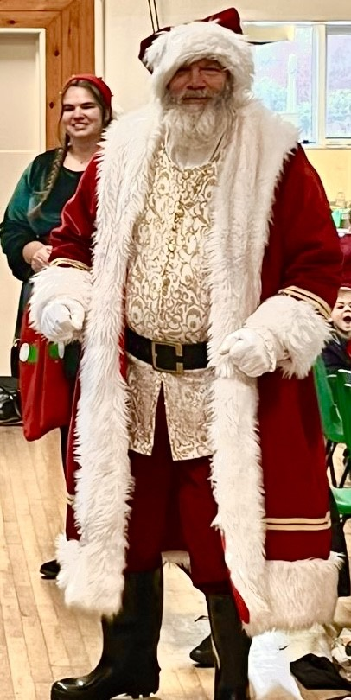
This final week of term kicked off with the wonderful opportunity to do their Christmas play! Everyone around Orchard Vale commented on the wonderful singing of Holywell children and I was so proud of the way they learned the play and managed in a completely different environment.

On Wednesday, we were so pleased to be able to visit Tawstock village hall for our Christmas dinner. Thank you to the Lauren and all the PTA for their support in arranging transport and helping us to decorate the hall. We even had a special visitor at the end of our fantastic dinner! A huge thank you to Emma for cooking such a wonderful meal and for all of her work through the year. We are very fortunate to have you all!
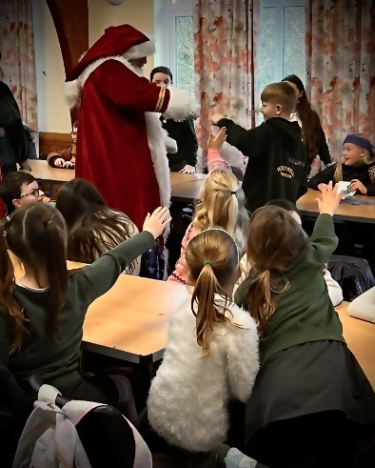
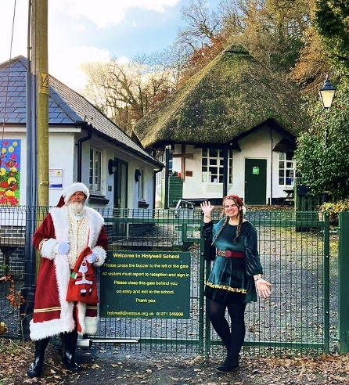

I also owe further thanks to Taw and Torridge, who provided us with a 50% discount on transport to enable us to go to the Christingle service. Of course, making the Christingles would not have been possible without the generous donations of oranges – another huge thank you to Emma Harding for organsing the oranges and bringing them up to the school.
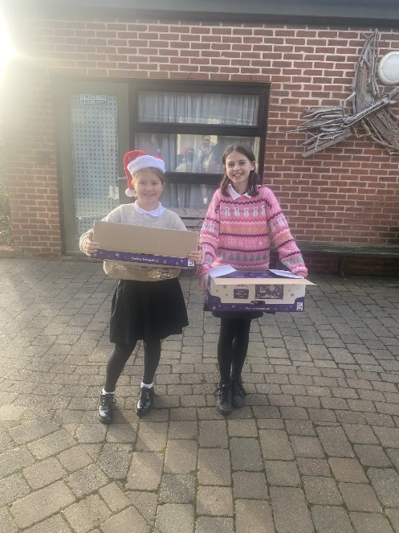
Today has been a wonderful last day of term in school. The children have enjoyed various festive activities and a lovely relaxed atmosphere in school. Earlier in the week, we were contacted by Tesco’s community team member, Sharon Ramsey thanks to the efforts of Mrs Proctor. A huge thank you to them both for their generous donation of selection boxes for the children! This has given them a lovely end to a busy term. I hope that you enjoy your festive treat, children! Mrs Proctor has also given up much of her personal time to help paint scenery and provide extras for the children this term – many thanks to you and all involved.

Finally, I must mention the fundraising that has been taking place through gofundme. I am aware that many parents have donated so generously, as have members of the local community. This has already gone some way towards making this Christmas a special one for the children and will go further into supporting the school in the new term. Many, many thanks to those who shared these ideas and set up the page as well as to those who have given so generously.
As I come to the end of my first year as Headteacher at Holywell, I reflect on the wonderful times that I have shared with our school already and I feel incredibly proud and privileged to be a part of this school community. Despite the recent challenges, you all show incredible spirit among staff and families and this only serves to make us think about the true meaning of Christmas. I am deeply proud of all of you and wish you all a very happy Christmas!
Best wishes,
Mrs Lowrey
A message from the PTA
Fundraiser for the School
Firstly, an enormous thank you to each and everyone that shared /donated to our fundraiser for the school.

We had no idea what to set the target at and were blown away to have this target of £500 smashed in just 52 minutes – amazing! We have now collected over £2000 – Thank you all so very much.
We will discuss with Mrs Lowrey and the School council in the New year about how best to spend this money, and of course update you all in due course.

Christmas Festivities
We have already spent some of the money on the coach that took the children to Tawstock Village hall for the Christmas lunch on Wednesday. TAW AND TORRIDGE COACHES reduced the cost of the coaches by 50% as a goodwill gesture – so a huge thank you to them too! After the Christmas lunch, the children were also surprised by Father Christmas and one of his elves. They handed out golden coins, which the children could swap after Christingle for a goodie bag from Santa. We hope the children enjoyed them!

We organised a raffle at the Christmas performances with two beautiful hampers up for grabs. The baskets that we filled had been very kindly donated by Mrs Tucker (Matilda and Oscars Gran) - thank you so much – they were perfect! Well done to the winners and thank you to everyone for buying tickets.

January Quiz
The Thorne/Parsons family are kindly organising a quiz night in January to raise money for the School. This will be held at Tawstock Village Hall, 13th January. Arrival 7pm for a 7:30pm start.

School News

Music Lessons
These will continue as normal but obviously at Roundswell. They will start on Monday8th and Thursday 11th January 2024.

Admissions policy for 2025-26: Annual Consultation
Along with all other schools and academies in Devon, we are consulting on an admission policy for 2025-26. The Local Authority is also consulting on its admission arrangements. You are invited to look at the proposals and have your say. Our proposed policy is on our admission page weblink and you can see all policies at http://devon.cc/schoolpolicy . Further information is here: www.devon.gov.uk/admissionarrangements

The consultation runs until 12 January 2024. Policies will be determined on 31st January 2024 and published in the same places by 15 March 2024.

Admissions to Reception Year for September 2024
Further details can be found at Apply for a reception or year 3 place at a primary school (devon.gov.uk) The Application window for the September 2024 Intake will open on 15th November 2023.

Useful Links and Information:
Here are some useful links that may assist you with your query
In Year Admission Information - Apply for an in-year place - Education and Families (devon.gov.uk)
School Catchment Area Checker - School designated (catchment) areas - Education and Families (devon.gov.uk)
Admission Advice for international arrivals Admission advice for international arrivals - Education and Families (devon.gov.uk)
Guide to School Appeals School admission appeals Archives - Education and Families (devon.gov.uk)

Links you may find useful
HANDi Paediatric app: advice for common childhood conditions - One Devon

Diary Dates
Dental Survey – Children Aged Year 5 – Wednesday 21st February. Please return the forms sent home.

Term Dates
End of Autumn Term – Friday 15th December 2023
Beginning of the Spring Term – Wednesday 3rd January 2024

School Uniform
We are in the process of moving our school uniforms sales from school to Daw’s at Daw’s Clothing Company Ltd, Unit 2 Affinity Devon, (Atlantic Village) Clovelly Road, Bideford.
As we sell out of items they are taking them on and can be purchased on-line at:
https://schoolthreads.org/collections/holywell-c-of-e

PE T-shirts will still be available to purchase from school.

Ventrus Job Vacancies
https://ventrus.current-vacancies.com/v?id=VENTRUSMUL&t=Ventrus-Careers
Including vacancies at local schools.

Free School Meals
Check if your child can get free school meals and additional funding support
All children in reception, year 1 and year 2 at state schools in England automatically get free school meals. However, parents and guardians are encouraged to apply for free school meals when they enrol their child in school, as this can help their child’s school to attract additional ‘pupil premium‘ funding to support learning.
From year 3 onwards, children whose parents are getting any of the following are entitled to free school meals:
- Universal Credit (provided you have an annual net earned income of no more than £7,400, as assessed by earnings from up to three of your most recent assessment periods).
- Income Support (IS).
- Income-based Jobseekers Allowance (IBJSA).
- Income-related Employment and Support Allowance (IRESA).
- The guaranteed element of State Pension Credit.
- Support under Part VI of the Immigration and Asylum Act 1999.
- Child Tax Credit (provided you’re not also entitled to Working Tax Credit and have an annual gross income that does not exceed £16,190).
- Working Tax Credit run-on (the payment you get for a further 4 weeks after you stop qualifying for Working Tax Credit).

How to apply
Apply through the Devon Citizens Portal. This is the quickest and easiest way to apply and will result in you getting an instant decision. Alternatively, call the Education Helpline on 0345 155 1019.

School Transport
https://www.devon.gov.uk/educationandfamilies/school-information/school-and-college-transport/
School and college transport – Education and Families
School transport information, including free school transport
www.devon.gov.uk

NEW Privacy Notices – November 2023
Important information
Ventrus main privacy notice can be found at https://ventrus.org.uk/our-people/privacy-notices/

Ventrus pupil privacy notice can be forum at https://ventrus.org.uk/wp-content/uploads/2022/11/Pupil-Privacy-Notice-2022-23-Academy-Ventrus-Nov-22.pdf

Community Information

TWO RIVERS MISSION COMMUNITY
Christmas 2023 at St Peter’s Tawstock

Christmas Starts Here You Are Invited

Community Carols in the Car Park Saturday 9 December 4:00pm Come join the Singing - Free Hotdogs & Mulled Wine

Nativity Sunday Family Service Sunday 17 December 11:00am The Instant Nativity, everyone welcome, come dress up and join in with the story. Followed by Tea, Coffee & Mince Pies

Carols by Candlelight Sunday 17 December 6:00pm Followed by Tea, Coffee & Mince Pies

Christmas Eve Communion by Candlelight Sunday 24 December 10:30pm

Christmas Day Celebration & Communion Monday 25 December 11:00am A short service of Celebration followed by Communion.

We also continue to hold a service every Sunday in December at 11.00am
St Peter’s Church Tawstock EX31 3HY

https://www.tworiversmissioncommunity.or

Museum of the Moon
Barnstaple is set to become the celestial centrepiece of North Devon this December, as "Museum of the Moon", a captivating artwork by UK artist Luke Jerram, lands in the newly regenerated Barnstaple Pannier Market.
Get ready to visit the market in a whole new light and immerse yourself in something truly extraordinary. This stunning artwork has been presented in over 300 different ways, across 30 different countries, and has captivated the hearts of more than 20 million people worldwide.
Don't miss your chance to be a part of this global sensation right here in Barnstaple! Secure your FREE place now to avoid disappointment – https://www.seetickets.com/tour/museum-of-the-moon
We understand that some visitors may prefer a quieter, calmer setting, which is why we have times available with enhanced lighting and lower music levels. Plus, we're limiting the number of available places to ensure everyone can fully immerse themselves in this experience. Book your experience now: https://www.seetickets.com/tour/museum-of-the-moon-relaxed-viewing
As well as the viewing of the moon, we have some additional activities running alongside, one being:
Family Silent Disco beside the Moon
North Devon Silent Disco and Silent Disco World bring you a unique Family Silent Disco like no other. The UKs Best Silent Disco Djs playing the most uplifting party tunes on the planet with Barnstaple’s historic Pannier Market lit up like you’ve never seen it before.
What better way to start the New Year than with a full family party in the shadow of Luke Jerram’s MOON!
Choose from three Channels of anthems, classics and sing-along bangers served up by the UKs top silent disco DJs.
80’s 90’s Naughties and NOW, Pop, Commercial, House, Garage, Rock, Hip hip, DnB
Buy your tickets now: https://www.seetickets.com/tour/family-disco-beside-the-moon
Venue: Barnstaple Pannier Market
Date: Monday 1 January 2024
Times: 2:30PM - 5PM
We hope you will join us.

