 |  | Newsletter | 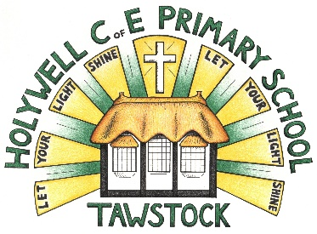  LET YOUR LIGHT SHINE  www.primaryschoolsbarnstaple.co.uk  holywell@ventrus.org.uk
Many other school events and news can be found on our Facebook page - click here

12th May 2023
Holywell is a NO NUT Zone.

Message from Mrs. Lowrey

Firstly, I must congratulate our Year 6 children on completing their SATs tests, which have taken place across the week. Children, your behaviour and attitudes towards your testing has been incredible! Throughout the year, you have shown so much enthusiasm and hard work in your learning and it has paid off for you. Every single one of you has performed to the best of your ability and I know Mrs Hammond and all of the other adults in the hall were so proud of what you have achieved. A huge well done to you all, you deserve a very relaxing weekend!

This week, Hedgehogs class have had their stunning start for their topic on Ancient Egypt!

I can also share some fabulous pictures from the Coronation Lunch last week, which looked amazing! Thank you Emma for the delicious food!

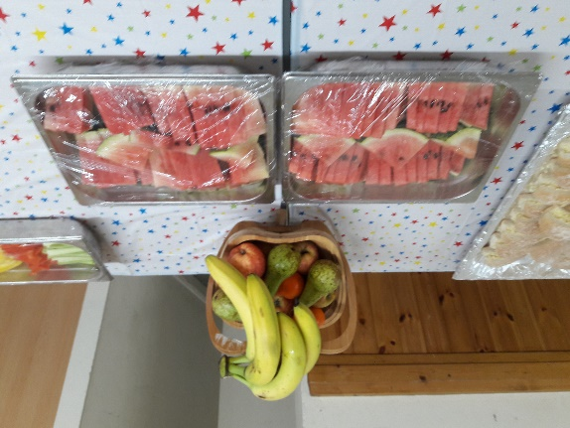
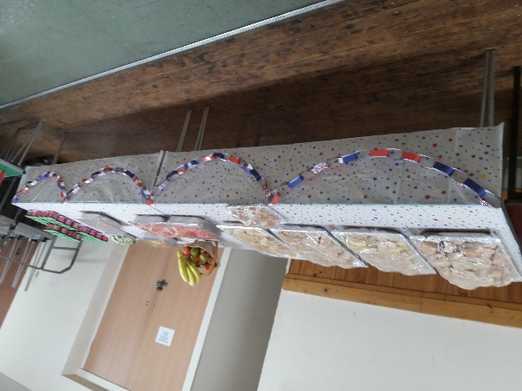

Today, we have waved farewell to Mrs Williamson, who is off to pastures new to start her new job. The children wished her and, of course, we know that she will be very missed by all of us. We wish her every success!

Apologies to all of you for last minute changes to clubs this week, I was called to support another school at short notice. Clubs, including welly walking, will be back on this week!

Please do scroll to the bottom of the newsletter for further fliers and information.

Have a wonderful weekend! Enjoy the sunshine! Mrs Lowrey

School News

Menu for Thursday 18th May, (see attachment)

School Uniform
We are in the process of moving our school uniforms sales from school to Daw’s at Daw’s Clothing Company Ltd, Unit 2 Affinity Devon, (Atlantic Village) Clovelly Road, Bideford.
As we sell out of items they are taking them on and can be purchased on-line at:
https://schoolthreads.org/collections/holywell-c-of-e

PE T-shirts will still be available to purchase from school.

ParentPay
The following trips are now available or will be available shortly for payment and consent to be made:
School Meals – £2.30 per day
Breakfast & ASC
Please remember to pay the correct funds into the correct account item, and for the correct child in your family

Parent Pay Debts.
Thank you to those of you who cleared your debts last week, we now currently have 26 children showing debts on their ParentPay school meals account. Can we please ask that you check your accounts over the weekend and pay these off as soon as possible?

Diary Dates
9th – 12th May – KS2 STAT’s week
12th June – Tempest – School and Class photos.

Term Dates
Summer Half Term – 29th – 2nd June 2023 – inclusive.
End of Term – last day Friday 21st July 2023.

Ventrus Job Vacancies
https://ventrus.current-vacancies.com/v?id=VENTRUSMUL&t=Ventrus-Careers
Including vacancies at local schools.

Free School Meals
Check if your child can get free school meals and additional funding support
All children in reception, year 1 and year 2 at state schools in England automatically get free school meals. However, parents and guardians are encouraged to apply for free school meals when they enrol their child in school, as this can help their child’s school to attract additional ‘pupil premium‘ funding to support learning.
From year 3 onwards, children whose parents are getting any of the following are entitled to free school meals:
- Universal Credit (provided you have an annual net earned income of no more than £7,400, as assessed by earnings from up to three of your most recent assessment periods).
- Income Support (IS).
- Income-based Jobseekers Allowance (IBJSA).
- Income-related Employment and Support Allowance (IRESA).
- The guaranteed element of State Pension Credit.
- Support under Part VI of the Immigration and Asylum Act 1999.
- Child Tax Credit (provided you’re not also entitled to Working Tax Credit and have an annual gross income that does not exceed £16,190).
- Working Tax Credit run-on (the payment you get for a further 4 weeks after you stop qualifying for Working Tax Credit).

How to apply
Apply through the Devon Citizens Portal. This is the quickest and easiest way to apply and will result in you getting an instant decision. Alternatively, call the Education Helpline on 0345 155 1019.

School Transport
https://www.devon.gov.uk/educationandfamilies/school-information/school-and-college-transport/
School and college transport – Education and Families
School transport information, including free school transport
www.devon.gov.uk

NEW Privacy Notices – November 2023
Important information
Ventrus main privacy notice can be found at https://ventrus.org.uk/our-people/privacy-notices/

Ventrus pupil privacy notice can be forum at https://ventrus.org.uk/wp-content/uploads/2022/11/Pupil-Privacy-Notice-2022-23-Academy-Ventrus-Nov-22.pdf

Community News
All Stars and Dynamos at your Local Cricket Club

With the many courses starting next week, your local Cricket Club still has capacity within their All Stars (5 – 8 years old) and Dynamos (8 – 11 years old) sessions to accept more bookings.

Attached is a Flyer promoting the All Stars and Dynamos opportunities in your local area

The link below provides further details on the two programmes.

https://ecb.clubspark.uk/AllStars/SearchResults?gclid=Cj0KCQjw6cKiBhD5ARIsAKXUdybT2Ll9IDO2DnF6r95JQJVOUxBIF80sGEA0F9U7LGldCO9ZettCygUaAqImEALw_wcB

