 |  | Newsletter | LET YOUR LIGHT SHINE  www.primaryschoolsbarnstaple.co.uk  holywell@ventrus.org.uk

19th October 2023
Holywell is a NO NUT Zone.

Message from Mrs. Lowrey

Non-Pupil Day Friday 20th October 2023
October Half Term Monday 23rd to Friday 27th October 2023
Return to school Monday 30th October 2023

What a fantastic way to end the half term, with a beautiful Harvest service at the church. A huge thank you to Reverend Cathy for her commitment to the school and to the community as well as to you all as parents and carers of the school. The numbers of families that attended just continues to demonstrate what a fantastic school community we have at Holywell. The children worked hard and did us proud. I will be transporting all donated goods to the Freedom centre – thank you for your generosity during this difficult time financially.
This week, I have been visited by many groups of children, sharing their writing, maths and other learning. I was delighted to share these fantastic DT projects that a group of Year 6 children have been making with Mrs Carlyon. Well done, Evan, Toby and Paddy!
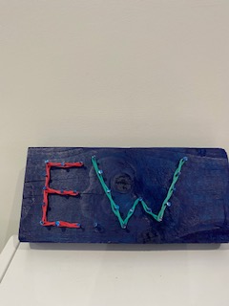
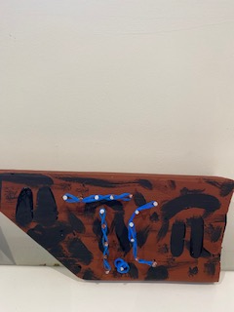
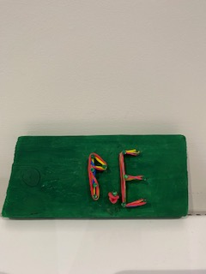

I also need to say a huge thank you to Mr Barstow, Mr Mead-Gomar and Mr and Mrs Coley, who all offered help at short notice to clear old and broken equipment from the school. The generosity of your time is greatly appreciated and I was astounded by how quickly our skip was filled! Thank you to the staff who all showed commitment to clearing our beautiful school site.

Thank you all for all of the support you have shown to me and to the school – I wish you all a lovely half term! Mrs Lowrey

Is my child to ill for school?
We are often being asked if a child should come to school if they are unwell so the DFE (NHS) have issued some guidelines. Please see the link below.
Is my child too ill for school? - NHS (www.nhs.uk)

School News

Year 5 & 6 Swimming
Thank you to those parents who have paid for the Swimming sessions this term. We have arranged on ParentPay that this can be paid in two instalments so if you have not yet paid can we please ask that you do this as soon as possible.

Choosing a secondary school for September 2024 entry? Please see Community News.
Admissions to Year 7 for September 2024.
Further details can be found at Apply for a secondary place – Education and Families (devon.gov.uk) The Application window for the September 2024 Intake opened on 1st September 2023 and closes on 31st October 2023
Admissions to Reception Year for September 2024
Further details can be found at Apply for a reception or year 3 place at a primary school (devon.gov.uk) The Application window for the September 2024 Intake will open on 15th November 2023.
Useful Links and Information:
Here are some useful links that may assist you with your query
In Year Admission Information - Apply for an in-year place - Education and Families (devon.gov.uk)
School Catchment Area Checker - School designated (catchment) areas - Education and Families (devon.gov.uk)
Admission Advice for international arrivals Admission advice for international arrivals - Education and Families (devon.gov.uk)
Guide to School Appeals School admission appeals Archives - Education and Families (devon.gov.uk)

Diary Dates
Year 5 & 6 Residential – Monday 30th October to Friday
Year 3,4,5 & 6 Cross Country - Thursday 9th November, at OV (afternoon event for 16 selected children)
Parent Conference - Tuesday 14th November – further details to follow.
Parent conference - Thursday 16th November – further details to follow.
Christmas Plays – Monday 4th December, further details to follow.
Christmas lunch and Christingle – Wednesday 13th December, further details to follow.
Christmas Jumper Days – for a one-off donation of £2.00 per child for Save the Children charity – Friday 1st December, Friday 8th December and Friday 15th December.

Term Dates

End of Autumn Term – Friday 15th December

LET’S TALK
A series of free online sessions for parents and carers of young people aged 9 – 12.
https://eur02.safelinks.protection.outlook.com/?url=https%3A%2F%2Fwww.eventbrite.co.uk%2Fe%2Flets-talk-pre-teens-september-2023-tickets-680101400597%3Faff%3Doddtdtcreator&data=05%7C01%7CElaine.Palmer%40ventrus.org.uk%7C07cef0981f874fda0a8108dbab7b83de%7C668515dda7fb41788c34b3c52dd93f70%7C1%7C0%7C638292319191735230%7CUnknown%7CTWFpbGZsb3d8eyJWIjoiMC4wLjAwMDAiLCJQIjoiV2luMzIiLCJBTiI6Ik1haWwiLCJXVCI6Mn0%3D%7C3000%7C%7C%7C&sdata=l7IDTWBJ9C6bdvG07OH5SWQyNG2Bo2X1sqarjZEJFC0%3D&reserved=0

School Uniform
We are in the process of moving our school uniforms sales from school to Daw’s at Daw’s Clothing Company Ltd, Unit 2 Affinity Devon, (Atlantic Village) Clovelly Road, Bideford.
As we sell out of items they are taking them on and can be purchased on-line at:
https://schoolthreads.org/collections/holywell-c-of-e

PE T-shirts will still be available to purchase from school.

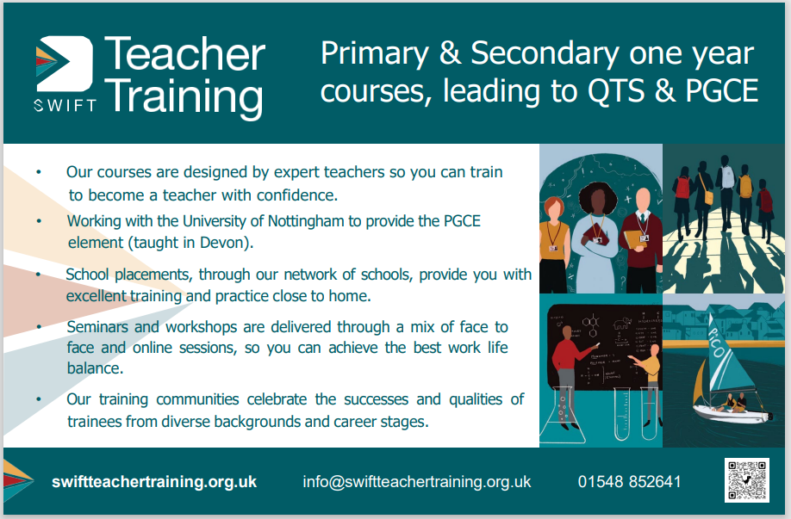

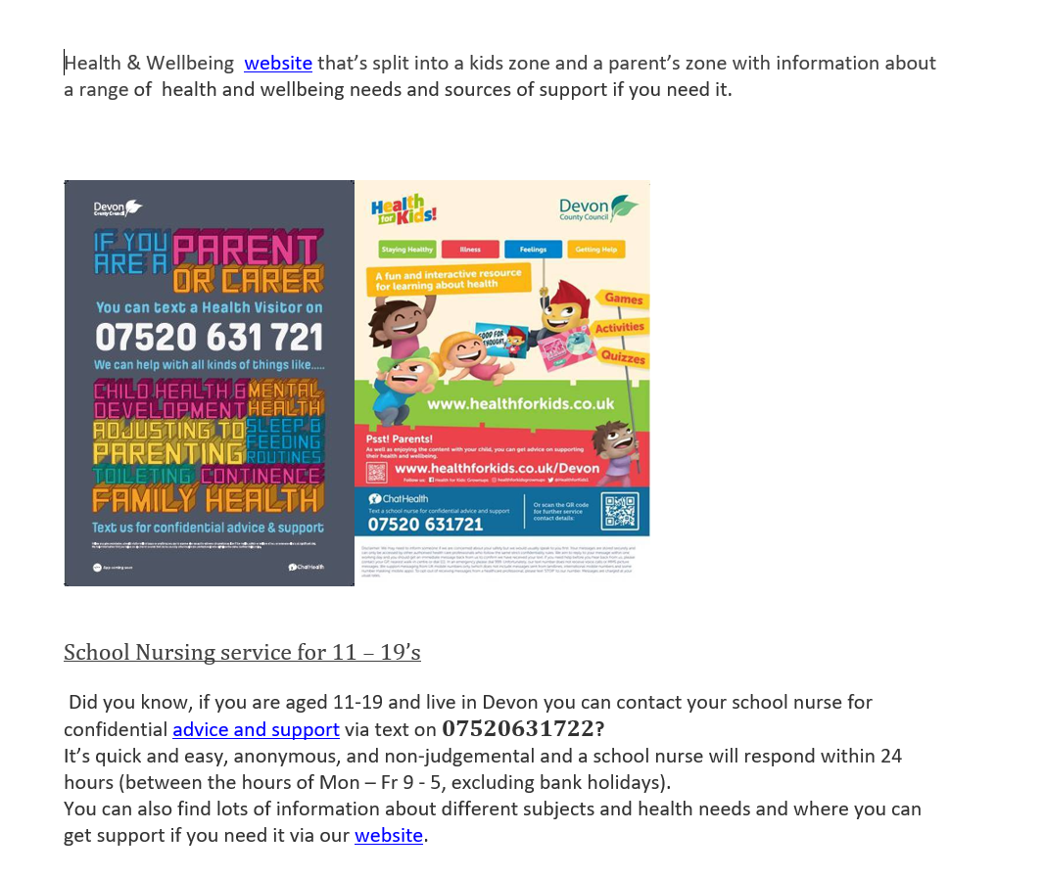
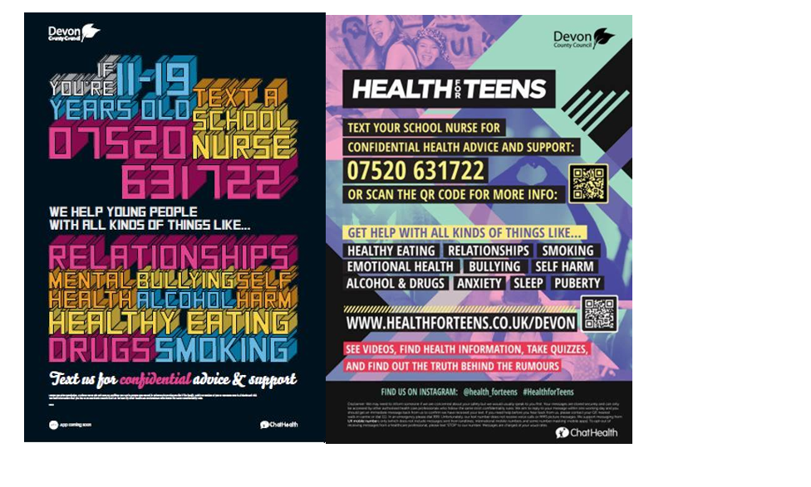

Ventrus Job Vacancies
https://ventrus.current-vacancies.com/v?id=VENTRUSMUL&t=Ventrus-Careers
Including vacancies at local schools.

Free School Meals
Check if your child can get free school meals and additional funding support
All children in reception, year 1 and year 2 at state schools in England automatically get free school meals. However, parents and guardians are encouraged to apply for free school meals when they enrol their child in school, as this can help their child’s school to attract additional ‘pupil premium‘ funding to support learning.
From year 3 onwards, children whose parents are getting any of the following are entitled to free school meals:
- Universal Credit (provided you have an annual net earned income of no more than £7,400, as assessed by earnings from up to three of your most recent assessment periods).
- Income Support (IS).
- Income-based Jobseekers Allowance (IBJSA).
- Income-related Employment and Support Allowance (IRESA).
- The guaranteed element of State Pension Credit.
- Support under Part VI of the Immigration and Asylum Act 1999.
- Child Tax Credit (provided you’re not also entitled to Working Tax Credit and have an annual gross income that does not exceed £16,190).
- Working Tax Credit run-on (the payment you get for a further 4 weeks after you stop qualifying for Working Tax Credit).

How to apply
Apply through the Devon Citizens Portal. This is the quickest and easiest way to apply and will result in you getting an instant decision. Alternatively, call the Education Helpline on 0345 155 1019.

https://eur02.safelinks.protection.outlook.com/?url=https%3A%2F%2Fwww.devon.gov.uk%2Feducationandfamilies%2Fschool-information%2Fschool-meals%2F&data=05%7C01%7CElaine.Palmer%40ventrus.org.uk%7Cecb748a1694549cf9d0d08dbab7b6f66%7C668515dda7fb41788c34b3c52dd93f70%7C1%7C0%7C638292318849767515%7CUnknown%7CTWFpbGZsb3d8eyJWIjoiMC4wLjAwMDAiLCJQIjoiV2luMzIiLCJBTiI6Ik1haWwiLCJXVCI6Mn0%3D%7C3000%7C%7C%7C&sdata=MPmLE78rMu0DP1khLjP7BHOHwf5yQWoQEPlCI7ngJO4%3D&reserved=0

School Transport
https://www.devon.gov.uk/educationandfamilies/school-information/school-and-college-transport/
School and college transport – Education and Families
School transport information, including free school transport
www.devon.gov.uk

NEW Privacy Notices – November 2023
Important information
Ventrus main privacy notice can be found at https://ventrus.org.uk/our-people/privacy-notices/

Ventrus pupil privacy notice can be forum at https://ventrus.org.uk/wp-content/uploads/2022/11/Pupil-Privacy-Notice-2022-23-Academy-Ventrus-Nov-22.pdf

‘Autism and Us’ Parent Programme (Autumn Term 2023):
Support from the Communication and Interaction Team - Education and Families (devon.gov.uk)
Support for parents/carers of Devon primary and secondary children who are either on the autism assessment waiting list or who have received a diagnosis of autism.
Our ‘Autism & Us’ programme delivered this academic year will once again be offered during the forthcoming Autumns term of the new 2023-24 academic year for parents/carers of Devon primary and secondary school children, pre or post diagnosis.
We are delighted to announce that we are offering access for families of CYP (Children & Young People) who are currently on the autism assessment pathway, in addition to families of CYP who have received an autism diagnosis.
Attending the ‘Autism & Us’ parent programme gives you an opportunity to develop your understanding of autism and look at practical solutions to managing and supporting your child’s presenting needs, whilst also connecting with other parents/carers.
Full programme details and application process below

Autism & Us programmes:
- 4 weekly ‘live online’ sessions (approx. 2hrs each) related to the following topic/themes:
No. | Topic | Programme 1 | Programme 2 | Trainer
1 | Autism overview |  | Tues 31 Oct - 4.30 – 6.30 | Paul Lamanna
2 | Communication |  | Tues 7 Nov - 4.30 – 6.30 | Laura O’Shea  + Melissa New
3 | Understanding and supporting behaviour |  | Tues 14 Nov - 4.30 – 6.30 | Laura Matthews
4 | Sensory | Thurs 12 Oct - 10 – 12 | Tues 21 Nov - 4.30 – 6.30 | Kevin Jones
Apply direct by email to: educationlearnersupport@devon.gov.uk
To secure a place on either of the above programmes or express your interest for forthcoming programmes. We will confirm your booking request, and provide you with a direct link to the event. They will be delivered online ‘live’ via the Microsoft TEAMs platform.

Additionally, we will also be offering the following very popular themed/topic-based workshops, which lead on from the above programmes for themes/topics that may be a priority area for you against your child’s presenting needs:

Topic | Date/Time | Trainer
Autism – Sensory processing + integration | Thurs 16 Nov 10-12 | Kevin
Autism and Girls | Wed 8 Nov 9.30-12 | Rob
Autism – Demand avoidance + PDA | Wed 6 Dec 10-12 | Rob
Autism – Communication (verbal – support strategies) | Tues 12 Dec 10-12 | Laura O  + Melissa
Autism – Managing stress + anxiety | Wed 15 Nov 10-12 | Alison
Autism – Vulnerability + online safety | Wed 1 Nov 10-12 | Paul
Autism – Communication (pre/non-verbal – support strategies | Wed 22 Nov 10-12 | Laura M
Apply direct by email to: educationlearnersupport@devon.gov.uk
To secure a place on any of the above topic-based workshops. We will confirm your booking request, and provide you with a direct link to the event. They will be delivered online ‘live’ via the Microsoft TEAMs platform.

Intercom Trust are now taking referrals for our new project – Family Pride Southwest. This will be available throughout Devon and Cornwall, including Plymouth and Torbay.

The project has 4 components.
Family Pride Events – fun family events for families where at least one member is LGBT+.
Parenting Support – We will be delivering Group Triple P for LGBT+ parents/carers with children between the ages of 2 and 12. This will be an 8-week course focussing on parenting skills.
Family Mediation – Our family practitioners can work with families where there is tension or communication problems between parents (together or apart). This can include disagreements on how best to support an LGBT+ child in the family.
Couples/co-parent counselling – We will have counselling available for parents who wish to work through difficulties in a therapeutic setting.

Families can book onto upcoming events via our Eventbrite page - https://www.eventbrite.co.uk/o/intercom-trust-17691399947. Alternatively, they can get in touch with our helpline to join the mailing list to be informed about upcoming events - 0800 612 3010 (9am – 4pm weekdays) or email helpline@intercomtrust.org.uk.
For parenting support, mediation or counselling, families can be referred, or can self-refer via the referral form on our website - https://www.intercomtrust.org.uk/referral-form/. Please select the Family Relationship Support option.

If you are interested you can find out more about the project - https://www.intercomtrust.org.uk/lgbt-families/ .

To ensure the project is effective we also have an advisory group to review our practice and evaluation. This would involve meeting virtually approximately once a month. Participation in these meeting would be on a voluntary basis, but we would reimburse expenses.

