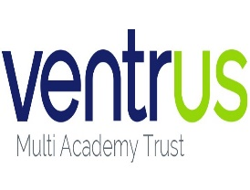 |  | Newsletter | LET YOUR LIGHT SHINE  www.primaryschoolsbarnstaple.co.uk  holywell@ventrus.org.uk

8th October 2023
Holywell is a NO NUT Zone.

Message from Mrs. Lowrey

Wow! What an amazing week we have had! There is so much to celebrate and I am delighted with the energy and enthusiasm of the children at this time of colds and illnesses – what terrific spirit the Holywell children show! This has been a week of sharing talents: from sporting talent at the cross-country to creative talents at the Shakespeare workshop.
Park Cross Country
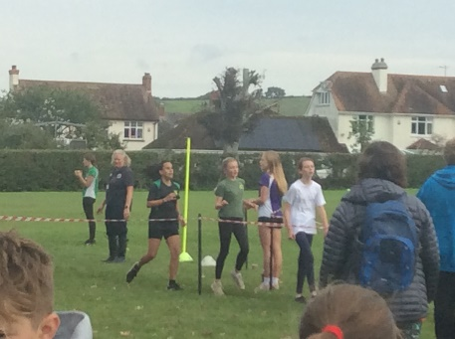
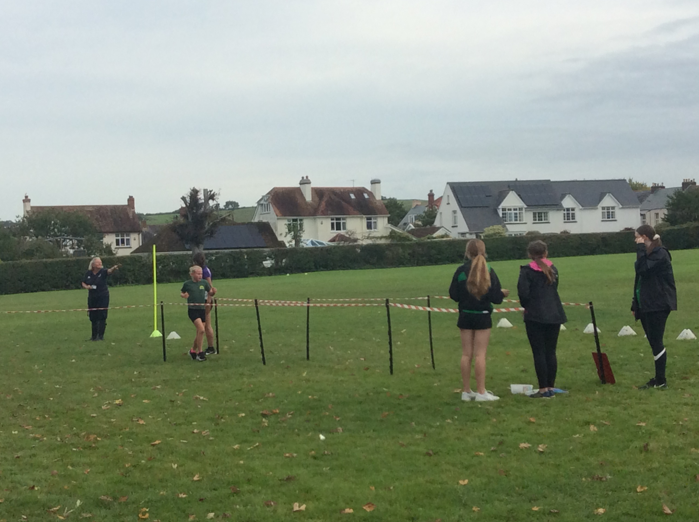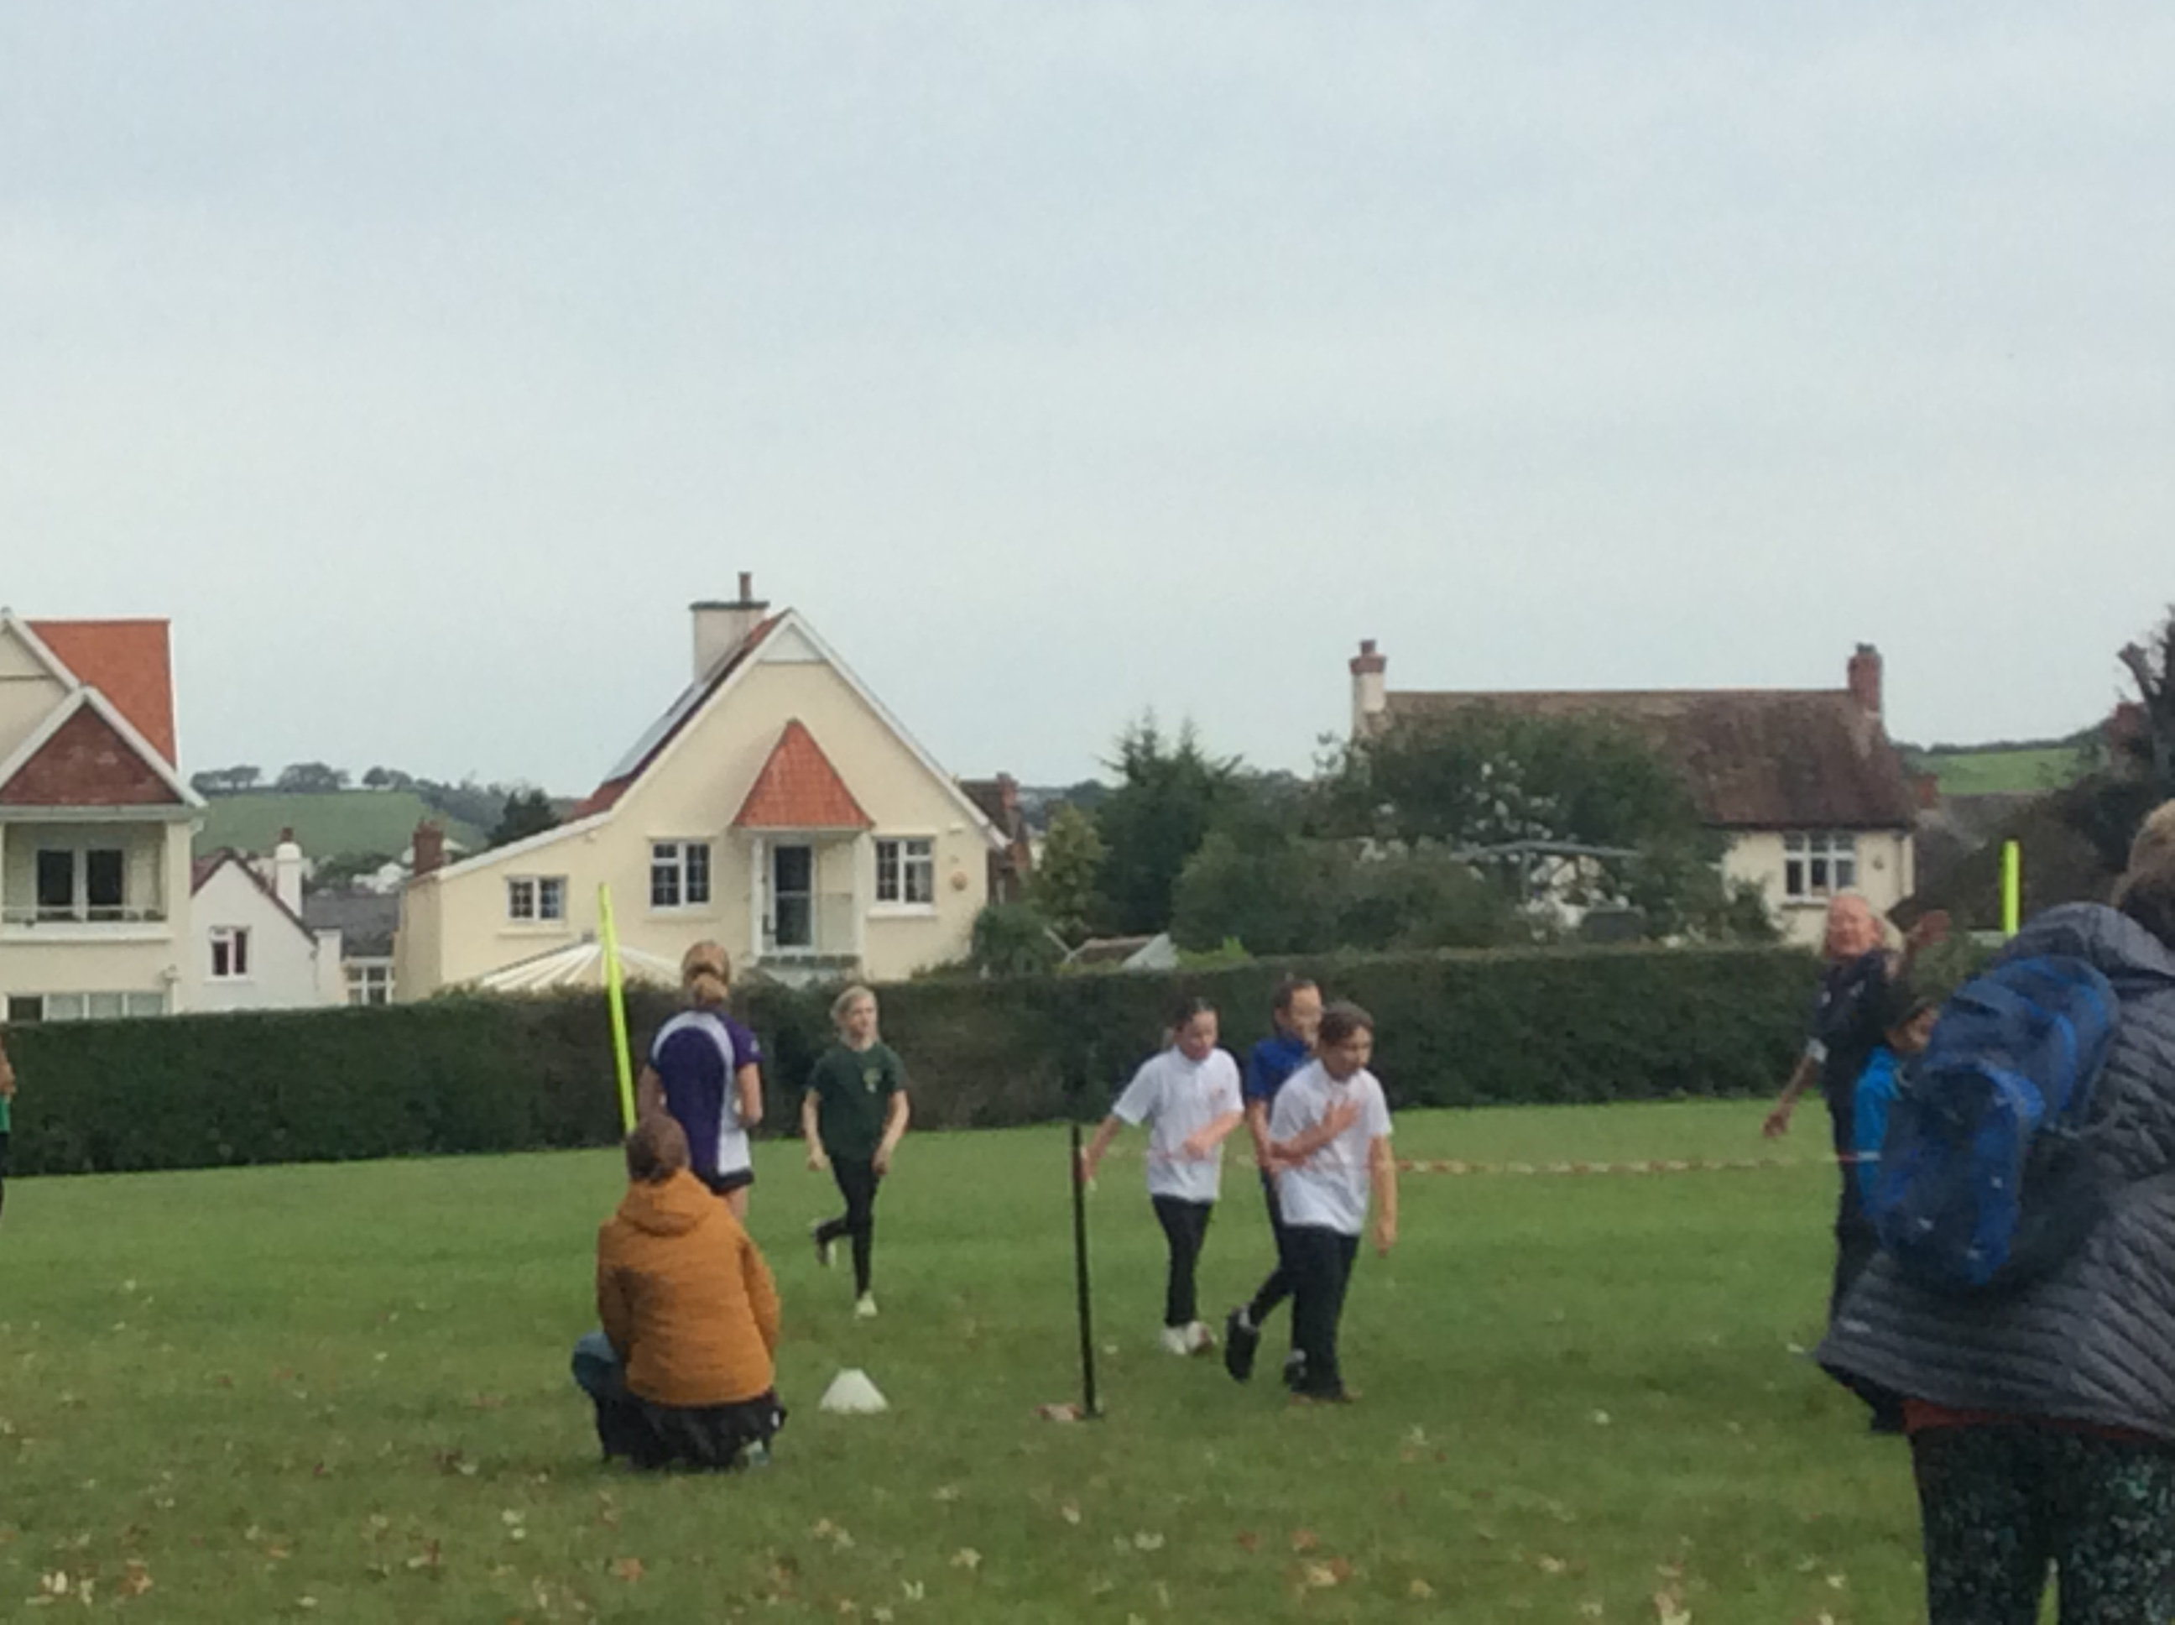
Miss Boundy, Mrs Scott and Mr Day were delighted to accompany our year 5/6 children to Park School for the cross country race on Thursday. I myself was incredibly proud of the sportsmanship and behaviour of our children, who represented the school incredibly well. It is a special moment as a Headteacher, when I dropped my daughter at her school the following day, that their staff complimented the Holywell children in this way. Congratulations to all of you, we are very proud of you. We had some fantastic achievements in running, including these children in the top places for the school.

Year 5 girls – Lola in 3rd Year 5 boys – Harvey – 22nd place
Year 6 girls – Olivia – 8th place Year 6 boys – Callan – 8th place
Ella – 11th place
Shakespeare workshop
Rehearsals are under way and beginning to take shape, in spite of the colds and bugs going around! Thank you to those of you who stepped in to read lines for others, it demonstrates your strong school values of supporting your friends. We were so excited to be visited by Alice and Lauren who work for the Coram Shakespeare for schools company. They provided us with an afternoon of games, voice and character development as well as creative ideas and top tips for the performance.
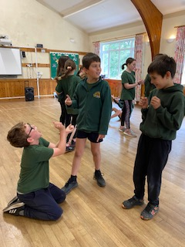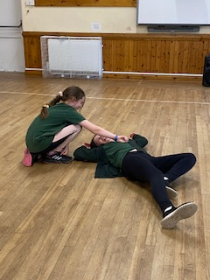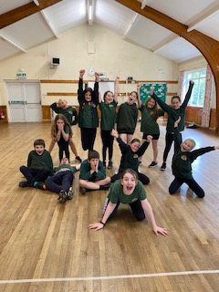

Can you help with costumes?
As we build up to the Shakespeare performance, I am looking for any help that you may be able to offer with costumes. Please could you let me know or bring in any of the following items:
- Linen shirts
- Waistcoats
- Flowered headbands – eg. Like garlands
- capes
If you are in the cast, please do not feel the need to buy something new, but if you have something at home that you think would be good for the show, speak to Miss Boundy or Mrs Lowrey.

Harvest
We will be walking to the church for our Harvest service on the afternoon of Thursday 19th October. The service will start at 2.30pm for a 3pm finish. We would like to invite all children to bring a small donation of dried or tinned goods for collection at the Harvest and we will donate all harvest goods to the Freedom Centre. Parents are very welcome to join us for the service and we would ask parents to please collect children from the church on this day.

Coffee morning – with Debbie Newman
Debbie Newman and Mrs Scott would like to invite you to a coffee morning in the village hall next Friday 13th October from 9am. This will be an opportunity for you to discuss common anxieties that children may face and the work that the Mental Health team do with children in school. Please do feel very welcome to attend and talk together with our community.

Headteacher/Teacher appointments
I wanted to say a huge thank you to you as a group of parents for contacting us through the school admin email address. I appreciate that this could slow down communication, but this has certainly helped the email traffic and supports us being able to make sure that emails are kept for reference.
We are always happy to speak to parents, however, please do know that it is very difficult for teachers to step out of class to talk at the gate. Should you have an urgent message, Mrs Lowrey and Mr Garrett will pass messages on or we are more than happy to make appointments to speak to you at a convenient time. Please could you email the school and ask for an appointment and we will arrange a mutually convenient time. This can also be arranged on Teams or phonecall if that is helpful.

This has turned into a bumper newsletter this week! I hope you enjoy the brief spell of forecasted sunshine. Best wishes, Mrs Lowrey

School News

Year 5 & 6 Swimming
Thank you to those parents who have paid for the Swimming sessions this term. We have arranged on ParentPay that this can be paid in two instalments so if you have not yet paid can we please ask that you do this as soon as possible.

Choosing a secondary school for September 2024 entry? Please see Community News.
Admissions to Year 7 for September 2024.
Further details can be found at Apply for a secondary place – Education and Families (devon.gov.uk) The Application window for the September 2024 Intake opened on 1st September 2023 and closes on 31st October 2023
Admissions to Reception Year for September 2024
Further details can be found at Apply for a reception or year 3 place at a primary school (devon.gov.uk) The Application window for the September 2024 Intake will open on 15th November 2023.
Useful Links and Information:
Here are some useful links that may assist you with your query
In Year Admission Information - Apply for an in-year place - Education and Families (devon.gov.uk)
School Catchment Area Checker - School designated (catchment) areas - Education and Families (devon.gov.uk)
Admission Advice for international arrivals Admission advice for international arrivals - Education and Families (devon.gov.uk)
Guide to School Appeals School admission appeals Archives - Education and Families (devon.gov.uk)

Diary Dates
Year 3 Multi Skills - Tuesday 17th October (morning event at Park School, children will need packed lunch)
All children
Harvest Festival – Thursday 12th October, further details to follow.
Year 3,4,5 & 6 Cross Country - Thursday 9th November, at OV (afternoon event for 16 selected children)
Parent Conference - Tuesday 14th November – further details to follow.
Parent conference - Thursday 16th November – further details to follow.
Christmas Plays – Monday 4th December, further details to follow.
Christmas lunch and Christingle – Wednesday 13th December, further details to follow.
Christmas Jumper Days – for a one-off donation of £2.00 per child for Save the Children charity – Friday 1st December, Friday 8th December and Friday 15th December.

Term Dates

LET’S TALK
A series of free online sessions for parents and carers of young people aged 9 – 12.
https://eur02.safelinks.protection.outlook.com/?url=https%3A%2F%2Fwww.eventbrite.co.uk%2Fe%2Flets-talk-pre-teens-september-2023-tickets-680101400597%3Faff%3Doddtdtcreator&data=05%7C01%7CElaine.Palmer%40ventrus.org.uk%7C07cef0981f874fda0a8108dbab7b83de%7C668515dda7fb41788c34b3c52dd93f70%7C1%7C0%7C638292319191735230%7CUnknown%7CTWFpbGZsb3d8eyJWIjoiMC4wLjAwMDAiLCJQIjoiV2luMzIiLCJBTiI6Ik1haWwiLCJXVCI6Mn0%3D%7C3000%7C%7C%7C&sdata=l7IDTWBJ9C6bdvG07OH5SWQyNG2Bo2X1sqarjZEJFC0%3D&reserved=0

School Uniform
We are in the process of moving our school uniforms sales from school to Daw’s at Daw’s Clothing Company Ltd, Unit 2 Affinity Devon, (Atlantic Village) Clovelly Road, Bideford.
As we sell out of items they are taking them on and can be purchased on-line at:
https://schoolthreads.org/collections/holywell-c-of-e

PE T-shirts will still be available to purchase from school.

Ventrus Job Vacancies
https://ventrus.current-vacancies.com/v?id=VENTRUSMUL&t=Ventrus-Careers
Including vacancies at local schools.

Free School Meals
Check if your child can get free school meals and additional funding support
All children in reception, year 1 and year 2 at state schools in England automatically get free school meals. However, parents and guardians are encouraged to apply for free school meals when they enrol their child in school, as this can help their child’s school to attract additional ‘pupil premium‘ funding to support learning.
From year 3 onwards, children whose parents are getting any of the following are entitled to free school meals:
- Universal Credit (provided you have an annual net earned income of no more than £7,400, as assessed by earnings from up to three of your most recent assessment periods).
- Income Support (IS).
- Income-based Jobseekers Allowance (IBJSA).
- Income-related Employment and Support Allowance (IRESA).
- The guaranteed element of State Pension Credit.
- Support under Part VI of the Immigration and Asylum Act 1999.
- Child Tax Credit (provided you’re not also entitled to Working Tax Credit and have an annual gross income that does not exceed £16,190).
- Working Tax Credit run-on (the payment you get for a further 4 weeks after you stop qualifying for Working Tax Credit).

How to apply
Apply through the Devon Citizens Portal. This is the quickest and easiest way to apply and will result in you getting an instant decision. Alternatively, call the Education Helpline on 0345 155 1019.

https://eur02.safelinks.protection.outlook.com/?url=https%3A%2F%2Fwww.devon.gov.uk%2Feducationandfamilies%2Fschool-information%2Fschool-meals%2F&data=05%7C01%7CElaine.Palmer%40ventrus.org.uk%7Cecb748a1694549cf9d0d08dbab7b6f66%7C668515dda7fb41788c34b3c52dd93f70%7C1%7C0%7C638292318849767515%7CUnknown%7CTWFpbGZsb3d8eyJWIjoiMC4wLjAwMDAiLCJQIjoiV2luMzIiLCJBTiI6Ik1haWwiLCJXVCI6Mn0%3D%7C3000%7C%7C%7C&sdata=MPmLE78rMu0DP1khLjP7BHOHwf5yQWoQEPlCI7ngJO4%3D&reserved=0

School Transport
https://www.devon.gov.uk/educationandfamilies/school-information/school-and-college-transport/
School and college transport – Education and Families
School transport information, including free school transport
www.devon.gov.uk

NEW Privacy Notices – November 2023
Important information
Ventrus main privacy notice can be found at https://ventrus.org.uk/our-people/privacy-notices/

Ventrus pupil privacy notice can be forum at https://ventrus.org.uk/wp-content/uploads/2022/11/Pupil-Privacy-Notice-2022-23-Academy-Ventrus-Nov-22.pdf

‘Autism and Us’ Parent Programme (Autumn Term 2023):
Support from the Communication and Interaction Team - Education and Families (devon.gov.uk)
Support for parents/carers of Devon primary and secondary children who are either on the autism assessment waiting list or who have received a diagnosis of autism.
Our ‘Autism & Us’ programme delivered this academic year will once again be offered during the forthcoming Autumns term of the new 2023-24 academic year for parents/carers of Devon primary and secondary school children, pre or post diagnosis.
We are delighted to announce that we are offering access for families of CYP (Children & Young People) who are currently on the autism assessment pathway, in addition to families of CYP who have received an autism diagnosis.
Attending the ‘Autism & Us’ parent programme gives you an opportunity to develop your understanding of autism and look at practical solutions to managing and supporting your child’s presenting needs, whilst also connecting with other parents/carers.
Full programme details and application process below

Autism & Us programmes:
- 4 weekly ‘live online’ sessions (approx. 2hrs each) related to the following topic/themes:
No. | Topic | Programme 1 | Programme 2 | Trainer
1 | Autism overview |  | Tues 31 Oct - 4.30 – 6.30 | Paul Lamanna
2 | Communication |  | Tues 7 Nov - 4.30 – 6.30 | Laura O’Shea  + Melissa New
3 | Understanding and supporting behaviour |  | Tues 14 Nov - 4.30 – 6.30 | Laura Matthews
4 | Sensory | Thurs 12 Oct - 10 – 12 | Tues 21 Nov - 4.30 – 6.30 | Kevin Jones
Apply direct by email to: educationlearnersupport@devon.gov.uk
To secure a place on either of the above programmes or express your interest for forthcoming programmes. We will confirm your booking request, and provide you with a direct link to the event. They will be delivered online ‘live’ via the Microsoft TEAMs platform.

Additionally, we will also be offering the following very popular themed/topic-based workshops, which lead on from the above programmes for themes/topics that may be a priority area for you against your child’s presenting needs:

Topic | Date/Time | Trainer
Autism – Sensory processing + integration | Thurs 16 Nov 10-12 | Kevin
Autism and Girls | Wed 8 Nov 9.30-12 | Rob
Autism – Demand avoidance + PDA | Wed 6 Dec 10-12 | Rob
Autism – Communication (verbal – support strategies) | Tues 12 Dec 10-12 | Laura O  + Melissa
Autism – Managing stress + anxiety | Wed 15 Nov 10-12 | Alison
Autism – Vulnerability + online safety | Wed 1 Nov 10-12 | Paul
Autism – Communication (pre/non-verbal – support strategies | Wed 22 Nov 10-12 | Laura M
Apply direct by email to: educationlearnersupport@devon.gov.uk
To secure a place on any of the above topic-based workshops. We will confirm your booking request, and provide you with a direct link to the event. They will be delivered online ‘live’ via the Microsoft TEAMs platform.

Intercom Trust are now taking referrals for our new project – Family Pride Southwest. This will be available throughout Devon and Cornwall, including Plymouth and Torbay.

The project has 4 components.
Family Pride Events – fun family events for families where at least one member is LGBT+.
Parenting Support – We will be delivering Group Triple P for LGBT+ parents/carers with children between the ages of 2 and 12. This will be an 8-week course focussing on parenting skills.
Family Mediation – Our family practitioners can work with families where there is tension or communication problems between parents (together or apart). This can include disagreements on how best to support an LGBT+ child in the family.
Couples/co-parent counselling – We will have counselling available for parents who wish to work through difficulties in a therapeutic setting.

Families can book onto upcoming events via our Eventbrite page - https://www.eventbrite.co.uk/o/intercom-trust-17691399947. Alternatively, they can get in touch with our helpline to join the mailing list to be informed about upcoming events - 0800 612 3010 (9am – 4pm weekdays) or email helpline@intercomtrust.org.uk.
For parenting support, mediation or counselling, families can be referred, or can self-refer via the referral form on our website - https://www.intercomtrust.org.uk/referral-form/. Please select the Family Relationship Support option.

If you are interested you can find out more about the project - https://www.intercomtrust.org.uk/lgbt-families/ .

To ensure the project is effective we also have an advisory group to review our practice and evaluation. This would involve meeting virtually approximately once a month. Participation in these meeting would be on a voluntary basis, but we would reimburse expenses.

