 |  | Newsletter | 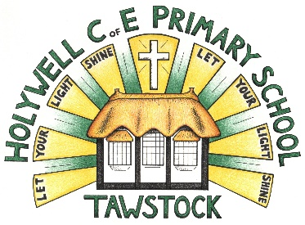  LET YOUR LIGHT SHINE  www.primaryschoolsbarnstaple.co.uk  holywell@ventrus.org.uk

12th January 2024
Holywell is a NO NUT Zone.

Message from Mrs. Lowrey

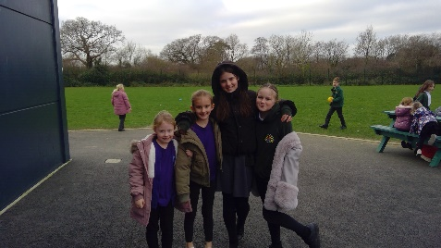
This week has been so much fun at Holywell. The children have settled well and are now focussed on their new learning topics and enjoying their subjects. I have been incredibly proud to see pieces of writing on display and maths work brought to me to share. Excellent job, everyone!

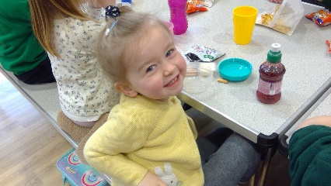
Thank you to those of you who have messaged about meal portions. This has mainly effected older children and appeared to be due to the school not being used to this age group on school site and are grateful to us for bringing it to their attention. The schools have worked together and adjusted meal portion sizes according to their age and the children have commented to me through the week that they are now feeling full after lunch.

Our KS2 children have been having French lessons from our friendly teacher at Pilton community college. It was a delight to listen to the children practicing their French today. Also, I am so proud of Edward S playing piano during worship today, this is really brave, Edward, especially in a completely different school. Well done, everyone!

Road closure
Thank you for your patience with transport and to those of you who have noticed that the road will be closed through Eastacombe next week. The bus company have been in touch with highways and they have agreed that the bus will be allowed to travel through at the start and end of the day, which is fantastic news. DCC are looking still to support us and this will be in place from 22nd January, but I do not yet have timings. It is likely to look very similar to our current offer.

I did mention parking last week, thank you so much for helping out both schools in this way. Please could I also clarify that we must not park in Brookside off Tews lane or block anyone in here as these spaces are allocated to the house owners in Brookside.

Mixed school ball games club – 8am-8.30am Fridays
RCPA and Holywell are keen to invite children from years 2, 3 and 4 to a ball games club at the above time on a Friday. This would be a fantastic opportunity for teachers and children to come together before school for a fun ball game activity. Please email the school if you are interested and mark for the attention of Miss Bellew. We will let you know next week if there is enough interest.

Please do share with the children that we are all incredibly proud of the way they have behaved so respectfully and with great enthusiasm as well as making new friends across the schools.
Best wishes and have a great weekend, Mrs Lowrey

School News
Next PTA Meeting
7pm on Monday 15th Jan
The Hunters Inn, Newton Tracy – everyone welcome.
If you cannot make it, but would like to make a suggestion re events, fundraising ideas or receive a copy of the minutes please email friendsofholywell@gmail.com

Bag2School
Collection planned for 24th January from outside Holywell School – by the benches as normal!

Dental Survey
These forms have been sent home again today with the reception our year 5 reception children.

SOE3’s and Consent forms – Reception, Year 1 and Year 2.
These forms were also sent home again this week as we require all forms returned for the children’s swimming next Tuesday.

School Contact
You can contact the school by phoning 01271 345908. If the phone is not answered, can you please leave a message on the answerphone. These messages will be responded to as soon as possible.

Admissions policy for 2025-26: Annual Consultation
Along with all other schools and academies in Devon, we are consulting on an admission policy for 2025-26. The Local Authority is also consulting on its admission arrangements. You are invited to look at the proposals and have your say. Our proposed policy is on our admission page weblink and you can see all policies at http://devon.cc/schoolpolicy . Further information is here: www.devon.gov.uk/admissionarrangements

The consultation runs until 12 January 2024. Policies will be determined on 31st January 2024 and published in the same places by 15 March 2024.

Admissions to Reception Year for September 2024
Further details can be found at Apply for a reception or year 3 place at a primary school (devon.gov.uk) The Application window for the September 2024 Intake will open on 15th November 2023.

Links you may find useful.
HANDi Paediatric app: advice for common childhood conditions - One Devon

Diary Dates
Dental Survey – Children Aged Year 5 – Wednesday 21st February. Please return the forms sent home.
Tennis Festival Year 4 - Wednesday 10th January – Tarka
Swimming Year R, 1 and 2 – 16th, 23rd and 30th January and 6th and 20th February. Please collect your child from the Tarka Leisure Centre at 3pm. Siblings will be looked after at Roundswell until you arrive.
Park School sports athletics - Friday 19th January - 12 children attending
World Book Day – March – more info to follow

Term Dates
Spring Half Term – Monday 12th February to Friday 13th February (inclusive).
End of Spring Term – Thursday 28th March 2024

School Uniform
https://schoolthreads.org/collections/holywell-c-of-e

PE T-shirts will still be available to purchase from school.

Ventrus Job Vacancies
https://ventrus.current-vacancies.com/v?id=VENTRUSMUL&t=Ventrus-Careers
Including vacancies at local schools.

Free School Meals
Check if your child can get free school meals and additional funding support.
All children in reception, year 1 and year 2 at state schools in England automatically get free school meals. However, parents and guardians are encouraged to apply for free school meals when they enrol their child in school, as this can help their child’s school to attract additional ‘pupil premium‘ funding to support learning.
From year 3 onwards, children whose parents are getting any of the following are entitled to free school meals:
- Universal Credit (provided you have an annual net earned income of no more than £7,400, as assessed by earnings from up to three of your most recent assessment periods).
- Income Support (IS).
- Income-based Jobseekers Allowance (IBJSA).
- Income-related Employment and Support Allowance (IRESA).
- The guaranteed element of State Pension Credit.
- Support under Part VI of the Immigration and Asylum Act 1999.
- Child Tax Credit (provided you’re not also entitled to Working Tax Credit and have an annual gross income that does not exceed £16,190).
- Working Tax Credit run-on (the payment you get for a further 4 weeks after you stop qualifying for Working Tax Credit).

How to apply
Apply through the Devon Citizens Portal. This is the quickest and easiest way to apply and will result in you getting an instant decision. Alternatively, call the Education Helpline on 0345 155 1019.

School Transport
https://www.devon.gov.uk/educationandfamilies/school-information/school-and-college-transport/
School and college transport – Education and Families
School transport information, including free school transport.
www.devon.gov.uk

NEW Privacy Notices – November 2023
Important information
Ventrus main privacy notice can be found at https://ventrus.org.uk/our-people/privacy-notices/

Ventrus pupil privacy notice can be forum at https://ventrus.org.uk/wp-content/uploads/2022/11/Pupil-Privacy-Notice-2022-23-Academy-Ventrus-Nov-22.pdf

