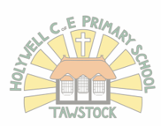l

**Holywell C of E Primary School**

**Spring Term 2022**

**Hedgehogs Class**

**Years 2 and 3**

**What will the children wonder about?**

Where is Australia?

How can I find Australia on a map?

How does Australia compare to the UK?

What is a continent?

Who is Queen Elizabeth?

What are the human and physical features of Australia?

What is the commonwealth?

What is a nation?

**Geographical Vocabulary**

Australia

map

continent

ocean

atlas

globe

city

commonwealth

aboriginal

**Wow products**

Rain maker

Lamingtons

Aboriginal art

**What will every learner experience?**

Australia Day - WOW

Bush Tucker Trial

**What novels and poetry will the learn through?**

An anthology of intriguing animals by Ben Hoare.

I don’t like Snakes by Nicola Davies

Hidden World: Ocean by Libby Walden & Stephanie Fizer Coleman

Could a Penguin ride a bike? Camilla Bedoyere