 |  | Newsletter | 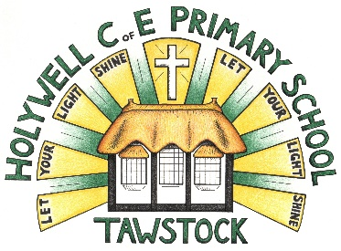  LET YOUR LIGHT SHINE  www.primaryschoolsbarnstaple.co.uk  holywell@ventrus.org.uk

22nd March 2024
Holywell is a NO NUT Zone.

Message from Mrs. Lowrey

Despite an unusual week this week, we have had a lot of learning to celebrate! Thank you for your support with this unforeseen episode of illness, hopefully Monday will bring a fresh return again to those who have been effected and that we continue to enjoy the last few days of school. Next week, we have a variety of Easter activities prepared for the children to enjoy!

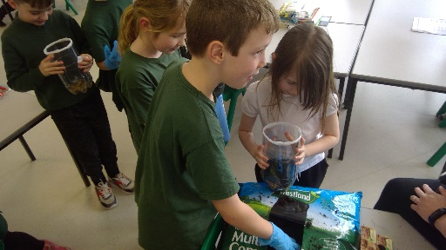
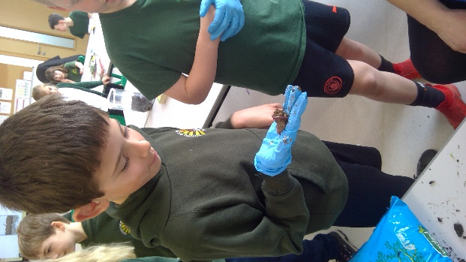
Some highlights of our week have been some super progress in reading with our Reception children, some excellent work being shared in maths and English and some wonderful, practical science looking at composting!
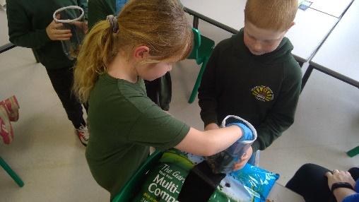
Next week, our Year 5/6 boys will be attending Tarka for an interschools football competition on Tuesday and Reverend Gary will be with us at the Easter Service on Wednesday. We will be transporting the children by bus to Tawstock for a 2pm start. You are all welcome to join us at the church, we would love to see you! On Wednesday, we are asking that all children are collected from the church at 3pm. Children who require after school club on this day will be transported back to Roundswell so please do collect from this site. Miss Boundy will be running her SATs boosters after school on Wednesday, again

Site update

I am delighted to update you that we anticipating that the work at the school site will begin before the Easter holidays. I am expecting that the clearance of the debris and clearing the classroom will begin next week, however, will need to confirm this on Monday. I have drafted a letter explaining the process that will be forwarded to you once I receive notice of the day that they are due to arrive in school, which will have been approved by Ventrus directors.

School

Links you may find useful.
HANDi Paediatric app: advice for common childhood conditions - One Devon

Diary Dates
Tuesday 26th March - Barnstaple boys football finals @ Tarka
Wednesday 27th March – Easter Church service – 2-3pm – please collect from the church
Thursday 28th March - Easter Treat – a tasty surprise from the PTA

Term Dates
Last day of the Spring Term – Thursday 28th March 2024
First day of the Summer Term – Monday 15th April 2024

School Uniform
https://schoolthreads.org/collections/holywell-c-of-e

PE T-shirts will still be available to purchase from school.

Ventrus Job Vacancies
https://ventrus.current-vacancies.com/v?id=VENTRUSMUL&t=Ventrus-Careers
Including vacancies at local schools.

Free School Meals
Check if your child can get free school meals and additional funding support.
All children in reception, year 1 and year 2 at state schools in England automatically get free school meals. However, parents and guardians are encouraged to apply for free school meals when they enrol their child in school, as this can help their child’s school to attract additional ‘pupil premium‘ funding to support learning.
From year 3 onwards, children whose parents are getting any of the following are entitled to free school meals:
- Universal Credit (provided you have an annual net earned income of no more than £7,400, as assessed by earnings from up to three of your most recent assessment periods).
- Income Support (IS).
- Income-based Jobseekers Allowance (IBJSA).
- Income-related Employment and Support Allowance (IRESA).
- The guaranteed element of State Pension Credit.
- Support under Part VI of the Immigration and Asylum Act 1999.
- Child Tax Credit (provided you’re not also entitled to Working Tax Credit and have an annual gross income that does not exceed £16,190).
- Working Tax Credit run-on (the payment you get for a further 4 weeks after you stop qualifying for Working Tax Credit).

How to apply
Apply through the Devon Citizens Portal. This is the quickest and easiest way to apply and will result in you getting an instant decision. Alternatively, call the Education Helpline on 0345 155 1019.

School Transport
https://www.devon.gov.uk/educationandfamilies/school-information/school-and-college-transport/
School and college transport – Education and Families
School transport information, including free school transport.
www.devon.gov.uk

NEW Privacy Notices – November 2023
Important information
Ventrus main privacy notice can be found at https://ventrus.org.uk/our-people/privacy-notices/

Ventrus pupil privacy notice can be forum at https://ventrus.org.uk/wp-content/uploads/2022/11/Pupil-Privacy-Notice-2022-23-Academy-Ventrus-Nov-22.pdf

